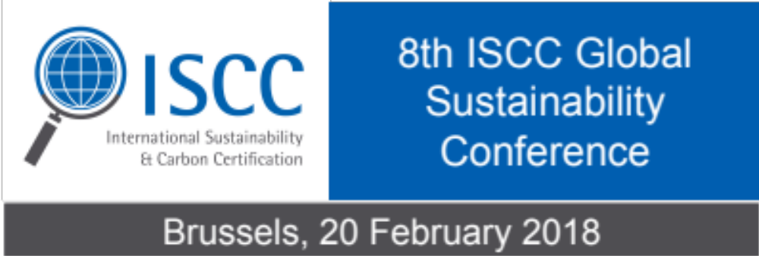

On Tuesday, 20 February 2018 the 8th ISCC Global Sustainability Conference is taking place in Brussels. A comprehensive programme awaits all interested parties, highlighting current challenges and innovative solutions regarding the future of bioenergy.

After the great success of the ISCC Global Sustainability Conferences in previous years, ISCC is very much looking forward to an illuminating upcoming conference. This important annual ISCC Conference is open to all interested parties and has been established as an important platform for industry, trade, NGOs, associations, research and authorities to present and discuss recent developments, challenges, opportunities and emerging trends in sustainability and sustainability certification. More than 200 participants are expected.

We have invited expert speakers from EU institutions and member states, United States, Brazil, associations and the industry. They will give you the latest updates on the RED II negotiations, the implementation of policies on advanced biofuels and waste/residues in Member States, insights in biofuels policies and opportunities in other regions of the world, and last but not least success stories and innovative solutions.

The attendance is free of charge.
To see the agenda and register your place please visit www.iscc-system.org
(link zur Event homepage: https://www.iscc-system.org/stakeholders/annual-iscc-global-sustainability-conference/

About ISCC
ISCC (International Sustainability & Carbon Certification) is a globally leading certification system for sustainable and deforestation free supply chains.
ISCC is being used in the energy, food, feed, and chemicals market.

Independent third party certification ensures compliance with high ecological and social sustainability requirements, greenhouse gas emissions savings and traceability throughout the supply chain.

Since its start of operation in 2010, over 16,000 certificates in more than 100 countries have been issued. ISCC is a multi-stakeholder initiative governed by an association with over 90 members from various stakeholder groups.
For further information please contact ISCC at info@iscc-system.org

